Date: Monday, October 23, 2017
Time: 4:00 – 5:00p.m.
Attendees: Susan Bell, Heather Brown, Elise Kearney, Suzanne Kingston, Terri Noll, Michelle Anderson, Kristi Mabee, Mr. Rabinowitz (Joan Roth excused)
Elise Kearney  CMS PTO President | - Introduction of fine arts team: Kristi Mabee for theatre and Mr. Rabinowitz for chorus. Discussion centered around available fine arts scholarships for students.  - Total scholarship budget is $1,000.  - Application must be completed  - Award based on ‘hardship’  PTO board will establish an application process and provide it to fine arts team (process will include why scholarship is needed, has student participated in team fundraising, chain of command, parameters, etc.). Elizabeth will be point of contact.  - Oct. 25 Parent/Teacher conference dinners update (Susan/Suzanne)  - 60 people expected for dinner from 4-4:45 on 10/25/17. Will be held in library. Set-up from 2-4:00p.m.  - Update on upcoming events/projects:  - Oct. 23 – Nov 6 Cookie Dough sale plan – ready to go!  - Oct. 24 – Family Dinner Night – Panda Express (flyer on PTO website)  - Plan of attack for Nov. 3rd Fall Pep Assembly – tape Mrs. Anderson “Always Breakin’ Records” to the wall!  - She will stand on a ‘short’ stool while students from two winning classes (Frain and Mulhern) tape her to the wall with duct tape. Stool will be removed when taping is complete and Mrs. Anderson will hang on the wall for the entire assembly!  - The two classes will be treated to a pizza and soda for raising $1,000 each for dodgeball competition. Pizza served before the assembly! A sign-up sheet will be given to both classes for ordering type of pizza and soda for efficiency!  - Change the day for our Exec. Board Meeting Mon., November 6 meeting moved to Tuesday., Nov. 7 at 4:00p.m. Not everyone will be able to attend, but this is the only time a majority can attend… others will be excused.
Michelle Anderson  Principal | - Topic for 11/13 Town Hall ‘Coffee Talk’ at 8:30a.m. 2-dozen Einstein bagels and coffee will be provided. Roars will be given to attendees!  - Dodgeball and Cookie Dough Sale results, Amazon Smile as fundraiser – Elise and Susan  - CMS’ academic & behavioral priorities – ‘moving up, catching up, keeping up’  - 2017 AZ Merit Data  - 90-day plan  - Terri won’t be attending – Elise will take notes  - PTO approved fine arts fundraising in December for Dessert night after concerts (possibly Just Desserts, Andes Custard, Yummies, Zoya) before December trip  - Cable system in the MPR – donate some money to fix it?  - Investigate options to provide curtains/repair cable system for curtains in MPR. Possibly $5,000-$7,000.  - Scholarships funds? $750 for Fine Arts Scholarships  - $1,000 available for scholarships  - PTO Board to develop procedures to apply for scholarships  - Donation letter for Fine Arts and getting donations from businesses  - PTO will prepare generic letter for soliciting donations from community businesses  - Needs of CMS – budget and thoughts of what we want to buy with our Dodgeball money (benches?)  - Wish list might include $ for: shade structure w/Colina, end of year gift ($4,000-5,000) to school (i.e., COW – computer on wheels)
Susan Bell  Advisory Member | PTO November newsletter info: Thanks to Hains family for managing the Roars Store, Cookie Dough Sale, Town Hall ‘coffee talk’, Chick-Fil-A FDN 11/28/17, Amazon Smile as fundraiser
Suzanne Kingston  Treasurer | Financial update
Open Items/  New Business | Next meetings:  - PTO Executive Board Meeting - 4-5:00p.m. – November 7, 2017  - Town Hall/ General PTO meeting – 8:30-9:30a.m. – November 13, 2017  - PTO Executive Board Meeting – 4-5:00p.m. – December 11, 2017

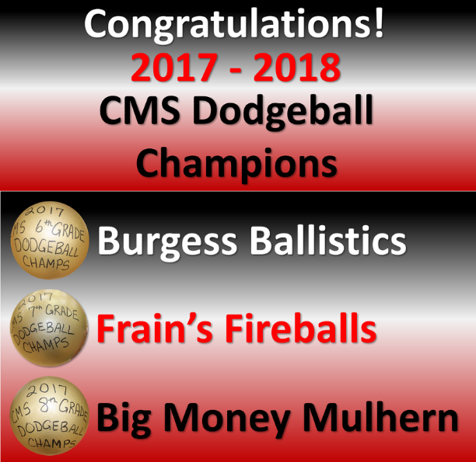
Mrs. Field’s Cookie Dough Sale
Monday, October 23 - Monday, November 6
(Product Delivery= Mid December)

